# Materials and Methods

## Measurement Set-up

The experimental set-up consisted of a single strawberry plant (*Fragaria × ananassa*), placed inside a growth chamber of 1.45 × 0.77 × 1.45 m (height × depth × width) (BIOCLIM 1600 US, Weiss Technik, Reiskirchen, Germany). Light intensity, temperature and relative humidity were controlled by a micro-controller board (Dwenguino, Dwengo vzw, Brussels, Belgium), placed outside the growth chamber. The temperature and relative humidity of the growth chamber were controlled using analogue signals, and varied randomly between 11°C and 33°C, and 31% and 75% respectively.

A custom-built frame of 1.00 × 0.70 × 1.10 m (height × depth × width) was inserted into the chamber. On top of which a grid of lamps was mounted, consisting of 32 LED lamps (MAS LED spot VLE D 4.9-50W GU10 927 60D, Koninklijke Philips N.V., Amsterdam, The Netherlands) and twelve halogen lights (DECOSTAR 51 PRO 50 W 12 V 36° GU5.3, OSRAM GmbH, Munich, Germany). The halogen lights were used as broadband light source, providing illumination in the visible and infrared range, while the LED lights increased the total Photosynthetically Active Radiation (PAR) while keeping thermal radiation within limits. The light intensity of the halogen lamps was controlled using a Digital Addressable Lighting Interface (DALI) controller and bus, while the LED lights were arranged in four sets that could be individually turned on and off. A detailed overview of the grid is depicted in fig. 1.

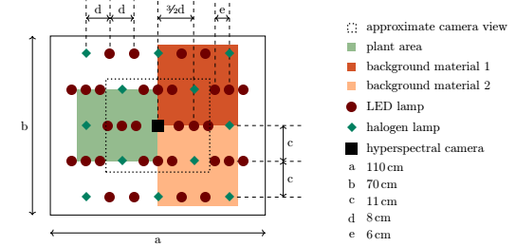

Figure 1: Schematic representation of the light and camera arrangement above the plant and background materials.

A single strawberry leaf was inserted into a transparent leaf chamber of the LI-6400XT photosyn-thesis system (LI-COR, Lincoln, NE, USA) to acquire gas exchange measurements (transpiration and photosynthesis). The control board also controlled the sampling time steps of the LI-6400XT, using a custom circuit that was connected to the manual sample button on the measurement node. To increase the carbon dioxide concentration in the growth chamber, a constant influx of stabilised air was used. This influx had a carbon dioxide concentration of 500 ppm at a rate of 1 m3h−1 . For environment sensing

at canopy height, we measured the temperature, light intensity and relative humidity. An external probe (Vaisala 50Y, Vaisala, Helsinki, Finland) was used to measure temperature and humidity. The gas ex-change device has a PAR probe to measure light intensity. This device was programmed to recreate the temperature measured using the probe inside the chamber, thus preventing the chamber from heating-up due to infrared radiation.

## Data Preparation and Processing

VIs are often used to extract meaningful information from image data, also in hyperspectral imaging (Vogelmann et al., 1993; Rouse et al., 1974; Gitelson and Merzlyak, 1994; Sims and Gamon, 2002; Gamon et al., 1992; Behmann et al., 2014; Jin and Wang, 2016; Gao et al., 2018; Alonso et al., 2017). However, only a limited and non-uniformly spaced number of bands are available here, limiting the possibilities to

use VIs from literature. Therefore, we generated a custom set of VIs. Based on literature, and taking practical limitations of the number of variables into account, we limited the created VIs to combinations of fractions of band pairs, summarised by eqs. (1) and (2). All possible combinations of two spectral bands were generated. Equation (1) is the fraction (F), and eq. (2) is the normalised fraction (NF) of a pair of bands. The model automatically selected the relevant indices thanks to regularisation (see below). The spectral bands from H1 were numbered 0 through 24, and those of H2 25 to 40. An index was only included if the absolute value of the maximum value of all Pearson correlation coefficients (ρ)

with already included indices was lower than 0.95. This boundary ensures that none of the features were (nearly) linearly dependent. Note that the included VIs need not be the same for the different data types since the correlation metric might differ. This technique could generate up to 2459 new features.

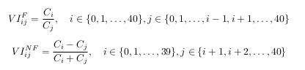

Normally, VIs are only generated on image data from plants, but we also generated them for the background materials to avoid bias due to the generation of possibly more informative features in the comparison between plant- and background-based models.

## Variables and Eco-physiological Meaning

The gas exchange measurement device (LI6400XT) produced the eco-physiological data to which

the hyperspectral image data was fitted. Different environmental and eco-physiological parameters were captured, providing a diverse set of target variables. An overview of the available variables is provided in table 1. All variables except for air temperature (T air ) and relative humidity (RH) were measured outside the area observed with the camera. This was a requirement due to the high reflectivity of the leaf chamber that resulted in an undesired exposure compensation of the camera.

